Gap Analysis:
Developing and Sustaining Nursing Leadership, Second Edition, July 2013
Work Sheet

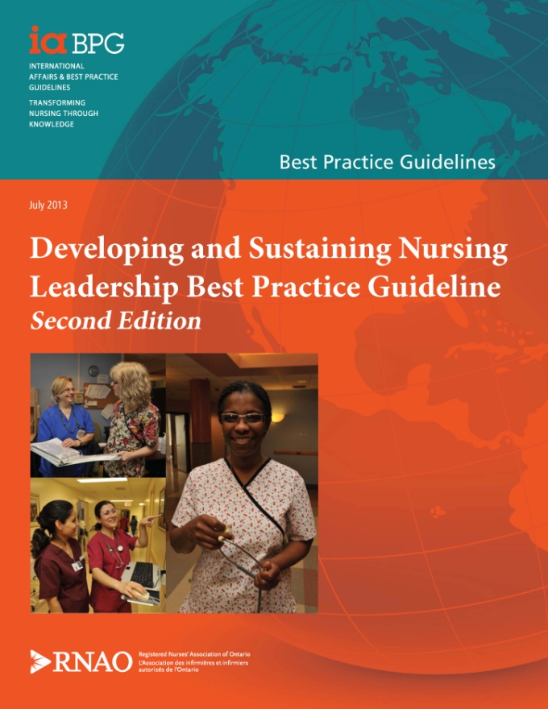
This guideline can be downloaded for free at:
http://rnao.ca/bpg/guidelines/developing-and-sustaining-nursing-leadership

The RNAO Leading Change Toolkit 3rd Edition
https://rnao.ca/leading-change-toolkit

What is a Gap Analysis?
A process comparing your organization’s current practice with evidence-based best practice recommendations to determine:
- Existing practices and processes that are currently implemented and supported by best practices. This information is useful to reinforce practice strengths.
- Recommendations that are currently partially implemented in practice. These would be good first targets for change efforts.
- Recommendations that are not currently being met.
- Recommendations that are not applicable to your practice setting.

Uses of a Gap Analysis
- Contributes to annual evaluation by allowing you to compare practice from year to year and choose which areas to focus on changing within the year.
- Focuses on needed practice change which prevents a total overhaul of practice and builds on established practices and processes.
- Informs next steps such as development of infrastructure to support implementation, stakeholder engagement, identification of barriers and facilitators, resource requirements, selection of implementation strategies and evaluation approaches.
- Leads to sustained practice change by informing plans related to process, staff and organization and reinforces current evidence based practices.

Conducting a Gap Analysis
Engage the team, and internal and external stakeholders as needed in gathering information for the gap analysis. Collect information on:

- Current practice – is it known and is it consistent? (met, unmet, partially met)
- Partially met recommendations may only be implemented in some parts of the home, or you may feel it is only half done.
- Are there some recommendations that must be implemented before others?
- Can any recommendations be implemented quickly? These are easy wins and build confidence in the change.
- Are there recommendations based on higher levels of evidence than others?
- Are there any barriers to implementation? These may include staffing, skill mix, budget, workload issues, etc.
- What are the time frames in relation to specific actions and people or departments who can support the change effort?
- Are there links with other practices and programs in the LTC home?
- Are there existing resources and education that your LTC home can access?
- Are there any must-do recommendations that are crucial to resident and staff safety?
What do Levels of Evidence mean?
After each guideline recommendation you will notice a level of evidence. A level of evidence is a ranking system used to describe the strength of results measured in clinical trials and other types of research studies.
Ia: Evidence obtained from meta-analysis or systematic reviews of randomized controlled trials, and/or synthesis of multiple studies primarily of quantitative research.
Ib: Evidence obtained from at least one randomized controlled trial.
IIa: Evidence obtained from at least one well-designed controlled study without randomization.
IIb: Evidence obtained from at least one other type of well-designed quasi-experimental study, without randomization.
III: Synthesis of multiple studies primarily of qualitative research.
IV: Evidence obtained from well-designed non-experimental observational studies, such as analytical studies or descriptive studies, and/or qualitative studies.
V: Evidence obtained from expert opinion or committee reports, and/or clinical experiences of respected authorities.

Next Steps
- Celebrate the recommendations you are meeting.
- Prioritize the areas you want to work on. Start with practice changes that can be made easily or are crucial to resident and staff safety. Start by reinforcing success and focusing on quick wins.
- These priority areas become the foundation for planning your program or implementing practice change.
- For more information on taking your gap analysis to the next level see the Leading Change Toolkit™ | RNAO.ca
Long-Term Care Homes:
Contact your Long-Term Care Best Practice Co-ordinator to assist you in completing a gap analysis. Visit RNAO.ca/ltc.

Date Completed:
Team Members participating in the Gap Analysis:

RNAO Healthy Work Environment Best Practice Guideline Recommendations | Met | Partially Met | Unmet | Notes  (Examples of what to include: is this a priority to our home, information on current practice, possible overlap with other programs or partners)
Leadership Recommendations
1. Nurse leaders use transformational leadership practices to create and sustain healthy work environments.
1.1 Nurse leaders build relationships and trust.
1.2 Nurse leaders create or contribute to an empowering work environment.
1.3 Nurse leaders create or contribute to an environment that supports knowledge integration.
1.4 Nurse leaders lead, support and sustain change.
1.5 Nurse leaders balance the complexities of the system, identifying and managing competing values and priorities.
Personal Recommendations
2. Nurse leaders continually develop their personal resources for effective leadership.
2.1 Nurse leaders exhibit a strong professional nursing identity.
2.2 Nurse leaders reflect on and take responsibility for the growth and development of their own leadership expertise.
2.3 Nurse leaders act as coaches and mentors to develop leadership expertise in others and further develop their own professional skills.
2.4 Nurse leaders cultivate professional and personal social supports.
Education Recommendations
3. Educational programs provide formal and point-of-care opportunities for leadership development for nurses.
3.1 Nursing leadership programs incorporate evidence-informed models and theories.
3.2 Nursing leadership programs offered through undergraduate, graduate and continuing education include formal and point-of-care opportunities for leadership.
Organization And Policy Recommendations
4. Health-service organizations provide supports for effective nursing leadership.
4.1 Health-service organizations demonstrate respect for nurses as professionals and their contribution to care.
4.2 Health-service organizations respect nurses as individuals.
4.3 Health-service organizations plan and provide opportunities for growth, advancement and leadership development, not only for nurses in formal leadership positions but also for nurses at the point-of-care.
4.4 Health-service organizations support empowerment, enabling nurses to be responsible and accountable for their professional practice.
4.5 Health-service organizations provide timely access to information, decision-support systems and the resources necessary for care.
4.6 Health-service organizations promote and support teams, collaborations and partnerships.
4.7 Health-service organizations support leaders to assist and facilitate change.
4.8 Health-service organizations give managers spans of control that enable effective nursing leadership.
4.9 Health-service organizations invest in training and succession planning to develop future leaders.
Structural Recommendations
5. Governments develop policies and provide resources that support effective leadership.
5.1 Governments in all provinces and territories establish a senior nurse leader as a policy advisor.
5.2 Governments in all provinces and territories provide links among these nurse leaders.
5.3 Governments in all provinces and territories establish a nursing advisory council.
5.4 Governments in all provinces and territories establish, fund and maintain programs for nursing leadership development.
5.5 Governments in all provinces and territories establish, fund and maintain programs of nursing leadership research.
6.0 Researchers partner with governments and educational and health-service organizations to conduct nursing leadership research.
6.1 Researchers study the impact of nursing leadership on nurses, patients/clients, organizations and systems.
6.2 Researchers develop, implement and evaluate a leadership intervention based on the Conceptual Model for Developing and Sustaining Nursing Leadership.
6.3 Researchers conduct research on health human resources planning for nursing leadership roles.
6.4 Researchers conduct research on nursing leadership education and development.
7.0 Health-service and educational accreditation bodies incorporate into their standards this guideline’s organizational support recommendations for formal and informal leaders.

